Andrew Stiles
CSD-430
Assignment 8: Project Part 3
10/12/2025

Index.jsp (updated)
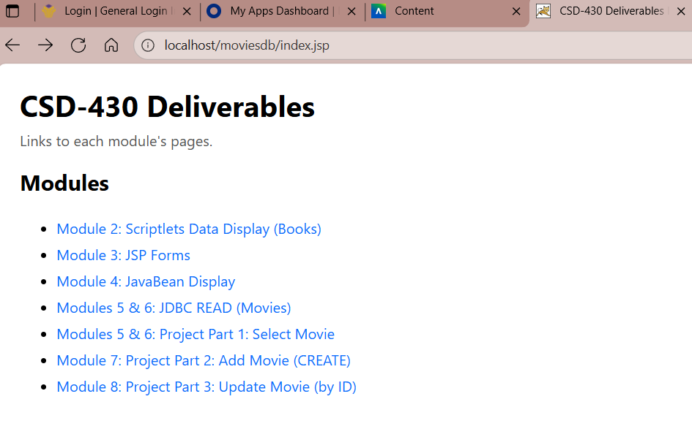
updateSelect.jsp
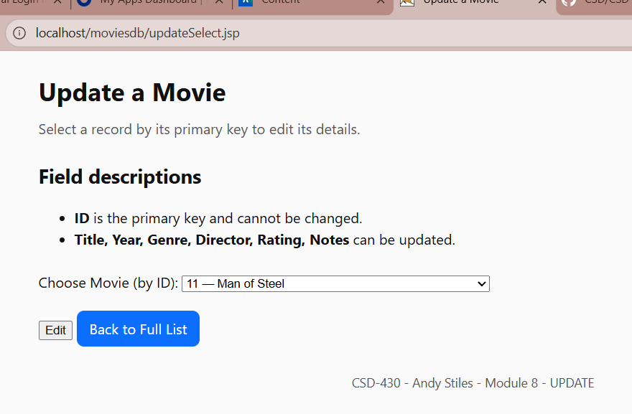

updateForm.jsp
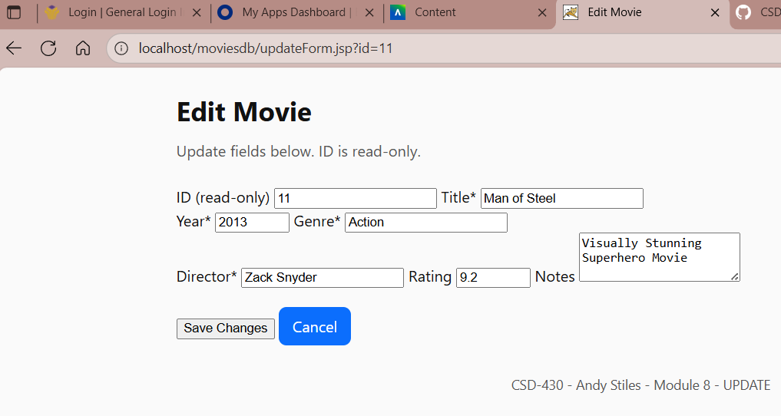

updateProcess.jsp
